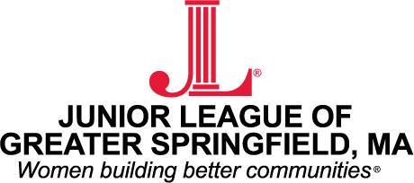

SPONSORSHIP TIERS FOR THE 2019 BEER & WINE TASTING

Diamond Sponsor - $2,000
- Company name and/or logo will be included on the event tickets.
- Will have the opportunity to display company signage in the lobby during the event.
- Will receive prominent recognition on the JLGS website and social media sites leading up to the event.
- Company name will be included in all press releases for the event.
- Will receive a full page ad in the event brochure and 10 tickets to the event.
Platinum Sponsor - $1,000
- Will have the opportunity to display company signage in the lobby during the event.
- Will receive prominent recognition on the JLGS website and social media sites leading up to the event.
- Company name will be included in all press releases for the event.
- Will receive a full page ad in the event brochure and six tickets to the event.
Gold Sponsor - $500
- Will receive prominent recognition on the JLGS website and social media sites leading up to the event.
- Company name will be included in all press releases for the event.
- Will receive a half page ad in the event brochure and four tickets to the event.
Silver Sponsor - $250
- Will receive recognition on the JLGS website and social media sites leading up to the event.
- Company name will be included in all press releases for the event.
- Will receive a quarter page ad in the event brochure.
Bronze Sponsor - $100
- Will receive recognition on the JLGS website and social media sites leading up to the event.
- Company name will be included in all press releases for the event.

SPONSORSHIP FORM:

Please sign my company up for a Beer & Wine tasting sponsorship at this level:

- Diamond Sponsor $2,000
- Platinum Sponsor $1,000
- Gold Sponsor $500
- Silver Sponsor $250
- Bronze Sponsor $100

Company: _________________________________________________
Contact: _________________________________________________
Address: _________________________________________________
_________________________________________________
Email: _________________________________________________
Phone: _________________________________________________

Please email a digital version of your logo to: jlgs.finance@gmail.com
Along with the completed form please make checks payable to Junior League of Greater Springfield and mail to the following address by March 1, 2019:

JLGS Inc.
P.O. Box 2634
Springfield, MA 01101

