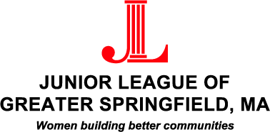

Junior League of Greater Springfield
Scholarship Application

PART 1: Application Information

PART 2: Scholarship Questionnaire

PART 3: Essay

PART 4: Required Recommendations

A) JLGS form completed by your high school guidance counselor. B) JLGS form completed by your volunteer supervisor.
Forms should be submitted with this application or mailed under separate cover to:

Junior League of Greater Springfield
c/o Elizabeth Kouflie
PO Box 2634
Springfield, MA 01101

Please send all materials paper-clipped, not stapled.

Application and all supporting materials must be postmarked by April 21, 2018.

